Week 4 Day 2 – 27th October, 2026(Tuesday)
Class demo notes and research notes-2
Question- What is generative ai and types of genai? Test, image, audio and video generation
CLASS DEMO NOTES
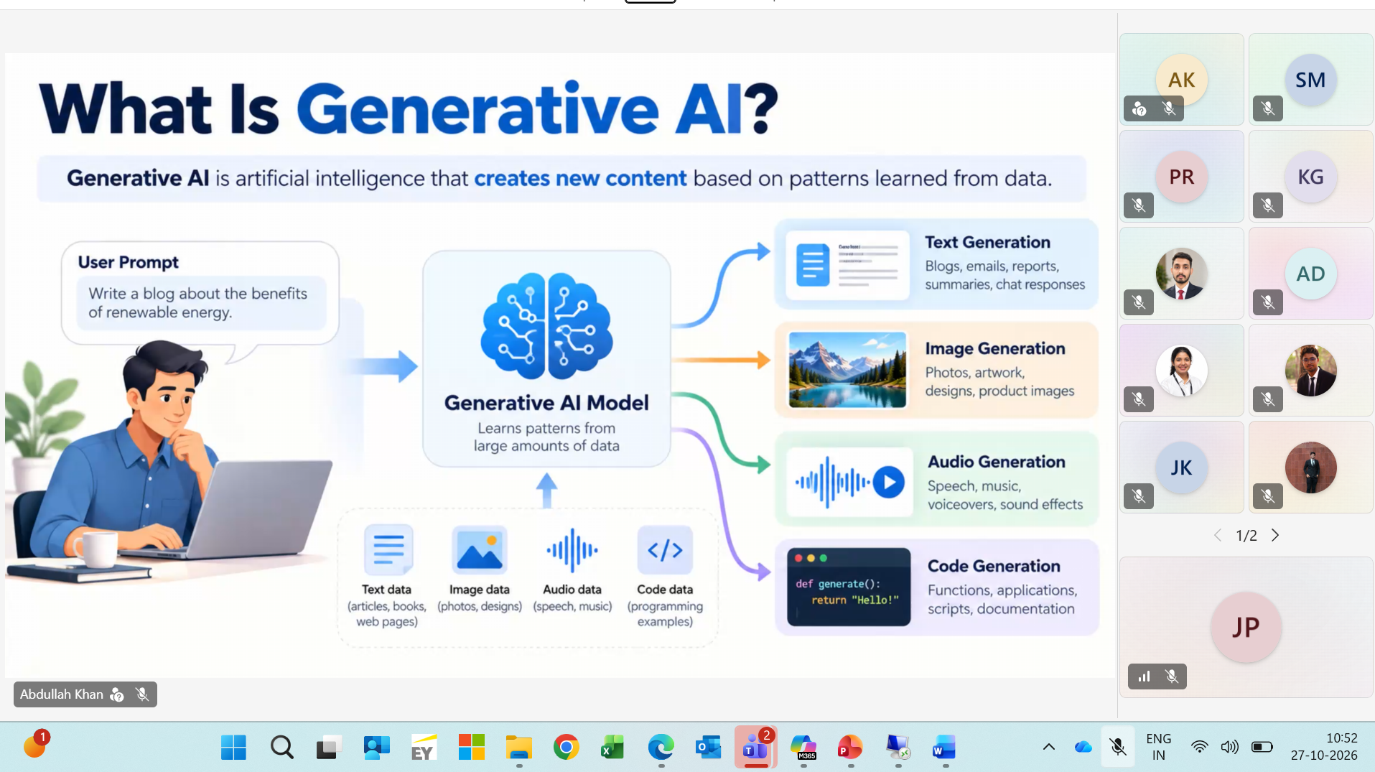
Audio -not very heavily used.
Claude is going for a IPO.
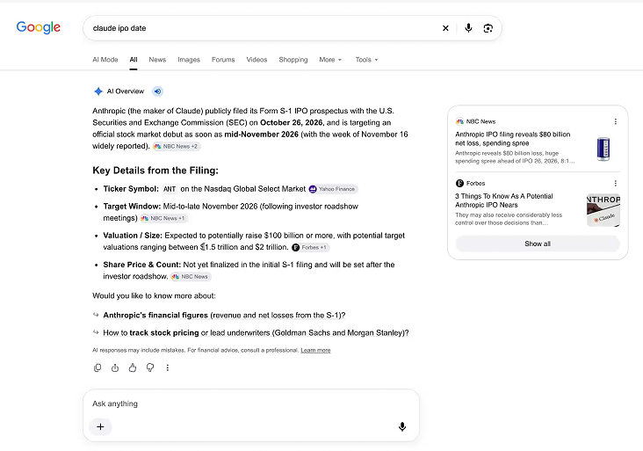
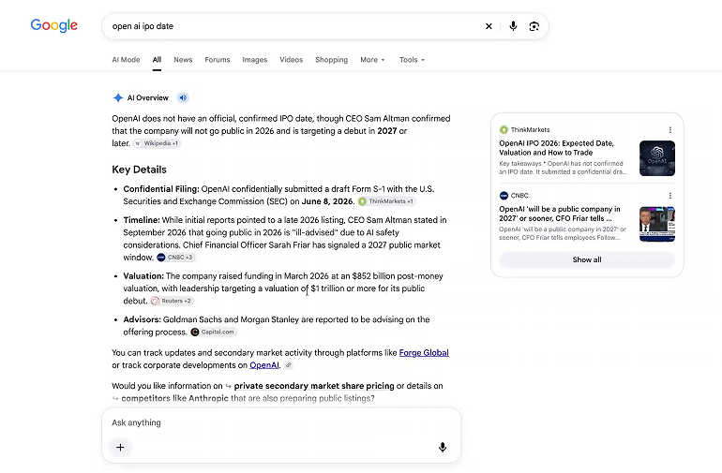
Claude for surveillance for US citizens (Claude disagreed, OpenAI working on this)
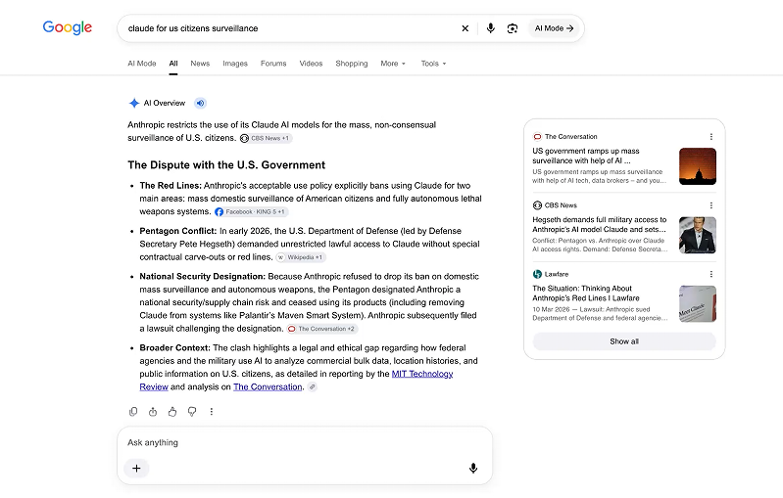
Pentagon US-if they acquire the model, they get controls of the govts of the world.
Google data centre in vizag forest clearance-environmental consequences
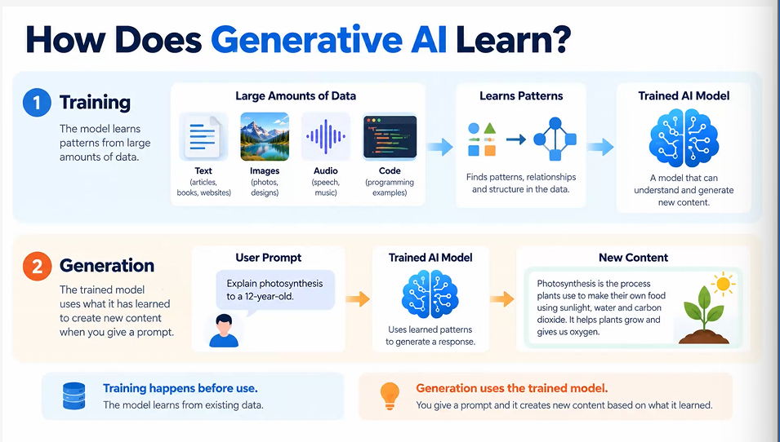
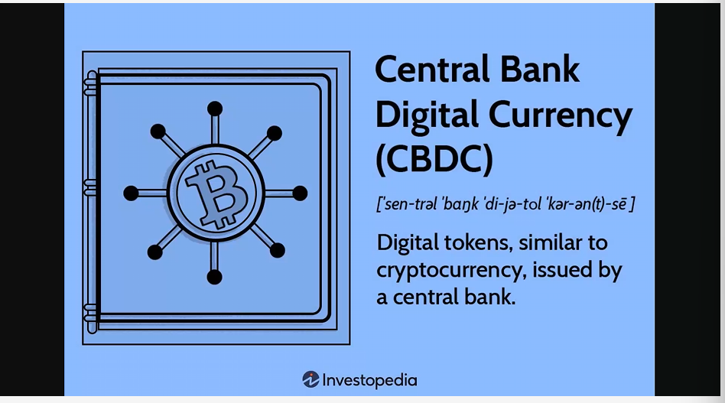
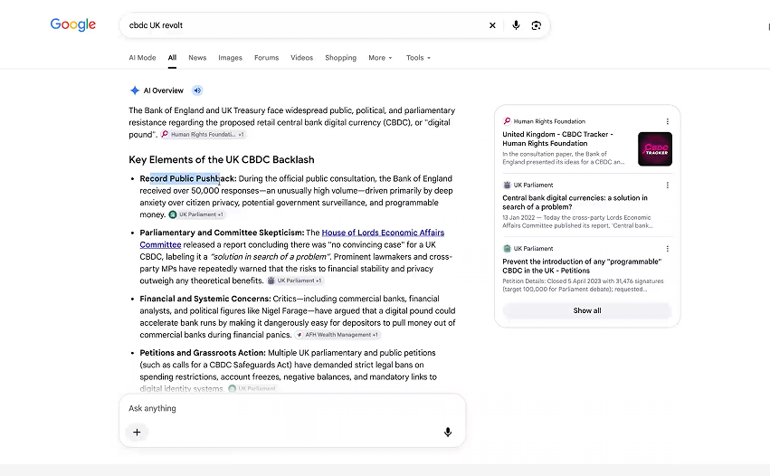
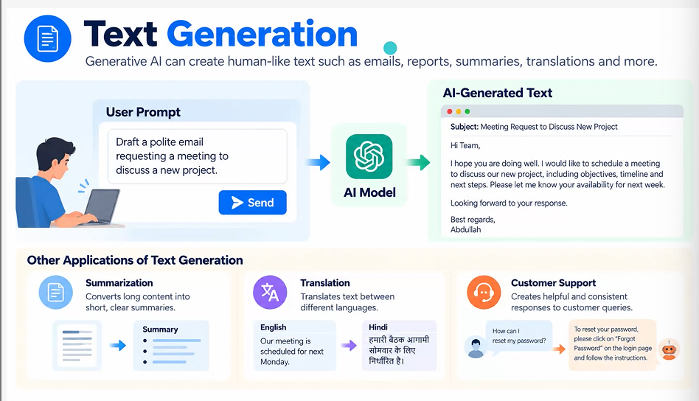
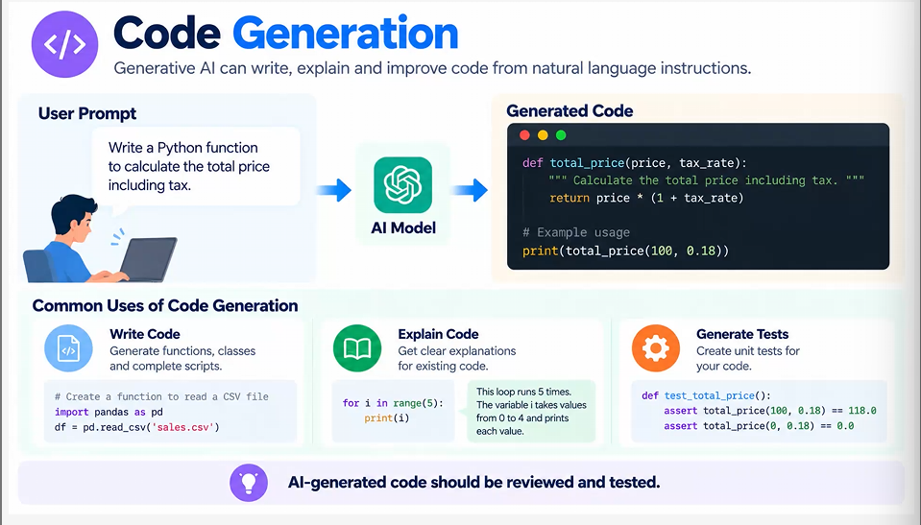
RESEARCH NOTES:FOUNDATION MODELS & ENTERPRISE AI
- Key models: GPT, DALL·E, Codex, Stable Diffusion
- What's Diffusion, GANs
- What are Transformers
- Applications in Enterprise AI (Use cases across industries)
Transformers, Diffusion, GANs and production use cases
1. The map: products are built from model families
GPT, DALL·E, Codex and Stable Diffusion are not four unrelated inventions. They are product/model lines built from reusable ideas: tokenization, embeddings, Transformers, latent representations, diffusion, post-training, retrieval and tools. A “model” learns a mapping or probability distribution; a “system” adds prompts, data connectors, safety, orchestration, monitoring and user experience.
Name | Primary output | Core idea | Best mental model
GPT | Text, reasoning-like responses, structured data | Autoregressive Transformer predicts the next token. | A probabilistic co-writer with a large learned pattern library.
DALL·E | Images from language and edits | Text-guided image generation; modern versions emphasize prompt adherence. | An illustrator translating verbal constraints into visual composition.
Codex | Code, tests, reviews and engineering actions | Code-specialized/agentic models combine language, repository context and tools. | A junior engineering agent that drafts, runs, checks and revises.
Stable Diffusion | Images and image edits | Latent diffusion denoises compact visual representations. | A sculptor turning controlled noise into an image.

- Foundation model: broadly pretrained on large, varied data.
- Specialized model: tuned or designed for a modality/task such as images or code.
- Application: wraps the model with enterprise data, permissions and process logic.
- Agent: a model-centered control loop that plans, calls tools, observes results and continues within limits.
Analogy: an engine is not a car. GPT or a diffusion model is the engine; retrieval, policy, identity, tools, telemetry and the interface make the enterprise vehicle.
Why this matters now
Stanford’s 2025 AI Index reported that 78% of surveyed organizations used AI in 2024, up from 55% in 2023; generative-AI private investment reached $33.9 billion. Capability is rising, but adoption value depends on workflow redesign, data quality, risk controls and measurable outcomes. [1]

2. GPT and Codex: generation through Transformers
GPT: Generative Pre-trained Transformer
Generative means it produces sequences; pre-trained means it first learns broad patterns from large corpora; Transformer names the attention-based architecture. Text is split into tokens, mapped to vectors, processed through many Transformer blocks, and decoded one token at a time. Training minimizes next-token prediction loss: L = -Σt log pθ(xt | x<t). Post-training then improves instruction following, preferences, safety and task behavior.
Inside one decoder block
Step | Layman meaning | Technical role
Token + position | Represent each piece and where it occurs. | Embeddings plus positional encoding/rotary position information.
Masked self-attention | Each token looks backward for relevant context. | Q=XWQ, K=XWK, V=XWV; softmax(QKᵀ/√dk)V with a causal mask.
Multi-head attention | Use several “views” of relationships. | Heads capture syntax, reference, locality and other learned patterns.
Feed-forward network | Transform each contextualized token. | Position-wise MLP; often the largest parameter share, sometimes MoE.
Residual + normalization | Preserve signal and stabilize depth. | Skip connections and normalization support optimization.

Analogy: while completing “The production database failed because…”, attention is a meeting in which every previous word submits evidence. The current token weighs the evidence, then chooses a probability distribution over possible continuations.
Codex: from code completion to engineering agent
The 2021 Codex model was described as a GPT-3 descendant trained on natural language and public source code. That original API-era model line was deprecated in 2023. By May 2025, “Codex” also referred to a cloud software-engineering agent, and current Codex materials emphasize multi-agent work, repository context, IDE/terminal use, code review and tool-assisted verification. Students should therefore distinguish historical Codex models from the evolving Codex product/agent. [2][3]
1 Context | 2 Plan | 3 Generate | 4 Execute | 5 Verify | 6 Review
Read issue, repo rules, dependencies and tests. | Break work into bounded changes. | Draft code and migrations. | Run in sandbox with least privilege. | Tests, lint, type-check, security scans. | Human reviews diff and approves merge.

Strengths and failure modes
- Strengths: natural-language interface, flexible transformation, few-shot adaptation, broad coding knowledge and tool use.
- Failures: fabricated APIs, outdated dependencies, hidden security flaws, prompt injection, incorrect assumptions and confident explanations.
- Controls: retrieval from approved sources, schema-constrained output, deterministic tests, scoped credentials, audit logs and approval gates.
Transformer research began as an attention-only sequence architecture that improved parallelism over recurrent models. Modern systems add longer context, sparse/MoE layers, multimodality, retrieval and agentic tooling, but attention remains the central organizing mechanism. [4]

3. DALL·E and Stable Diffusion: language becomes imagery
DALL·E: a product line, not one fixed architecture
The original DALL·E was introduced in 2021 as a 12-billion-parameter GPT-3-style Transformer trained on text-image pairs and generated image tokens autoregressively. DALL·E 3 later emphasized stronger prompt following and integration with a conversational system that expands and refines prompts. This illustrates a key lesson: a product name may persist while the internal generation stack evolves. [5][6]
Stable Diffusion: open, latent and controllable
Stable Diffusion popularized latent diffusion: an autoencoder compresses pixels into a smaller latent space; a denoiser learns to reverse noise in that space; a text encoder supplies semantic conditioning; and a decoder reconstructs pixels. Compared with pixel-space diffusion, latent processing cuts computation and enables practical fine-tuning, adapters, inpainting and self-hosting.

Component | Input → output | Why it exists
Text encoder | Prompt → semantic embeddings | Provides concepts, attributes and relationships for conditioning.
VAE encoder | Pixels → compact latent | Reduces spatial computation while preserving perceptual content.
Denoiser: U-Net or DiT/MMDiT | Noisy latent + condition → noise/velocity estimate | Learns the iterative reverse process.
Sampler/scheduler | Step t → step t-1 | Controls the numerical denoising path, speed and quality.
VAE decoder | Final latent → pixels | Returns a viewable image.
Guidance/control | Prompt, mask, depth, pose or reference | Improves adherence and supports editing/composition control.

Analogy: DALL·E/Stable Diffusion do not search a warehouse for one finished picture. A diffusion system begins with visual static and repeatedly asks, “Which noise should be removed so the remaining structure better matches this prompt?”
Stable Diffusion 3 and current direction
Stable Diffusion 3 introduced a Multimodal Diffusion Transformer architecture with separate weights for image and language representations and multiple text encoders. Stability AI’s Stable Diffusion 3.5 line offers Large, Turbo and Medium variants; the vendor positions Turbo for high-quality generation in four steps and Medium for consumer hardware. Treat vendor comparisons as product claims and validate on your own prompts, cultures and risk categories. [7][8]
Prompt-to-image engineering example
Marketing brief → “solar-powered cold-chain delivery in rural terrain” → brand-approved prompt template → generate four compositions → reject unsafe/inaccurate imagery → human selects → design tool adds exact typography and legal copy → provenance and approval stored. Image generation accelerates ideation; it should not be the final authority for factual diagrams, regulated claims or brand text.

4. Diffusion and GANs: two ways to learn visual realism
Diffusion: learn to reverse corruption
Forward process: gradually add Gaussian noise to a clean sample x₀ until it resembles noise xT. Training samples a time step t and teaches a neural network to predict the added noise, velocity or score. Reverse process: start from xT and iteratively estimate xT-1 … x₀. Conditional diffusion injects text, class labels, images or control maps through cross-attention or related conditioning.
Simplified objective: E[x₀, ε, t] ||ε - εθ(√ᾱt x₀ + √(1-ᾱt)ε, t, c)||². The model learns a direction back toward likely data given condition c. The equation is less important than the idea: corrupt deliberately, then learn recovery.
GANs: a generator and critic improve through competition
A GAN contains generator G(z), which maps random noise z to a sample, and discriminator D(x), which predicts whether a sample is real. Classic training is a minimax game: minG maxD Edata[log D(x)] + Ez[log(1-D(G(z)))]. The generator receives a learned quality signal rather than a pixel-by-pixel target.
Analogy: diffusion is a restoration apprentice practicing how to clean progressively damaged paintings. A GAN is a counterfeiter and an inspector training against one another; as the inspector detects flaws, the counterfeiter adapts.
Dimension | Diffusion | GAN
Training signal | Denoising/reconstruction-like objective. | Adversarial game between two networks.
Sampling | Usually iterative; can be accelerated/distilled. | Often one forward pass, therefore very fast.
Quality/diversity | Strong fidelity and coverage; controllable. | Sharp outputs, but diversity can collapse.
Stability | Generally stable but compute-intensive. | Sensitive balance; oscillation and mode collapse.
Enterprise fit | Editing, content generation, synthetic data, multimodal media. | Real-time synthesis, super-resolution, domain-specific generation.
Current convergence | DiTs, flow matching, consistency/distillation. | Latent-space Transformer GANs and hybrid distillation approaches.

Research update
A 2025 survey groups efficiency work for diffusion at algorithm, system and framework levels because generation cost and latency remain deployment barriers. Research revised in June 2026 reported Transformer-based latent GAN scaling and a single-step ImageNet-256 result, showing GAN research remains active even though diffusion dominates many general-purpose image tools. These are research findings, not blanket production superiority. [9][10]
Decision heuristic
- Choose diffusion when controllability, editing, diversity and broad prompt following matter.
- Consider GANs when extremely low latency, a narrow domain and controlled data justify specialized training.
- Benchmark total workflow cost: accelerator time, latency, moderation, failed generations, human review and licensing.

5. Enterprise AI architecture: model + knowledge + controls
Reference architecture
Layer | Typical components | Design question
Experience | Chat, search, IDE, contact center, workflow UI | What decision or task is being improved?
Orchestration | Prompt templates, routing, agents, state, tool selection | Which steps may the model control?
Knowledge | RAG, vector/keyword search, metadata, graph, citations | Which trusted evidence is allowed and current?
Model services | GPT/LLM, embedding, image/diffusion, code model | Which model meets quality, latency, residency and cost needs?
Tools/actions | APIs, databases, CRM/ERP, code runners, ticketing | What permissions, validation and transaction limits apply?
Guardrails | Input/output policy, DLP, moderation, grounding checks | How are unsafe or unsupported outputs blocked?
Platform | Identity, secrets, network, observability, evaluation, CI/CD | Can every action be traced, tested and rolled back?

End-to-end grounded workflow
User request → classify intent/risk → authenticate and authorize → retrieve approved evidence → construct bounded context → select model/tool → generate structured candidate → validate citations/schema/policy → request human approval for high-impact action → execute → log outcomes → sample for evaluation and improvement.
Analogy: an enterprise GenAI system is a well-run airport. The model is the aircraft, but value and safety require navigation data, air-traffic rules, identity checks, maintenance, human operators and incident procedures.
Build, buy, fine-tune or retrieve?
Pattern | Use when | Watch for
Prompt + managed model | Fast experimentation; generic knowledge/task. | Data handling, variability and lock-in.
RAG | Facts change or must be cited from enterprise sources. | Poor chunking, access leakage, stale indexes, wrong retrieval.
Fine-tuning/adapters | Stable behavior/style or narrow repeated task. | Training quality, drift, evaluation and maintenance.
Self-hosted/open weights | Residency, customization or unit economics justify operations. | Infrastructure, patches, safety and license obligations.
Agent + tools | Multi-step work requires verified external actions. | Prompt injection, runaway loops, privilege and irreversible actions.

Evaluation before rollout
- Quality: correctness, groundedness, task completion, image fidelity, code test pass rate.
- Operations: latency percentiles, throughput, cost per successful task, availability.
- Risk: harmful-output rate, data leakage, disparate performance, attack success rate.
- Business: cycle time, rework, conversion, resolution rate and user adoption versus a baseline.
Production principle: use probabilistic models inside deterministic control boundaries. The higher the consequence, the stronger the evidence requirement, validation and human approval.

6. Applications across industries: from assistance to action
High-value use cases

Industry | Generative/Transformer use | Image/diffusion or GAN use | Control that matters
Financial services | Research synthesis, service assistance, policy Q&A, developer productivity. | Synthetic scenarios/documents for testing; controlled creative assets. | PII, suitability, explainability, fraud and human sign-off.
Healthcare & life sciences | Clinical-document drafting, literature review, trial operations, coding assistance. | Imaging augmentation, molecule/protein exploration, educational visuals. | No autonomous diagnosis; privacy, provenance and clinical validation.
Manufacturing | Maintenance copilots, work instructions, root-cause support, code for automation. | Synthetic defect images, design variants, simulation assets. | Plant safety, verified procedures, edge latency and IP.
Retail & CPG | Product descriptions, service, localization, analytics narratives. | Campaign concepts, virtual scenes, packaging ideation. | Brand accuracy, rights, demographic bias and factual claims.
Technology | Coding agents, migration, test generation, incident summaries. | UI assets, synthetic training data, media generation. | Sandboxing, secrets, dependency risk and mandatory review.
Public sector/Education | Accessible content, translation, case/document assistance, tutoring. | Training graphics, simulations and localized learning media. | Transparency, accessibility, records rules and equitable outcomes.

Worked example: claims-document assistant
Input: a reviewer receives a claim form, photographs and policy documents. Pipeline: OCR and vision extraction → classify document types → retrieve the correct policy clauses → GPT produces a structured summary with clause-level citations → anomaly rules flag conflicts → a human reviewer decides. Optional diffusion-generated images may support training simulations, but must never be inserted as evidence. Outcome metrics: handling time, factual error rate, citation precision, escalation rate and customer-impact defects.
Common failure: automating the wrong thing
A fluent answer can hide a broken process. If source data is inconsistent, ownership is unclear or the decision cannot be evaluated, adding GenAI increases speed without increasing truth. Start with a bounded workflow, explicit evidence, reversible actions and a baseline. Scale only after measuring quality and risk by user group and scenario.
References:
- GPT/Transformers: use for language, code and multimodal sequence tasks; ground facts and verify outputs.
- DALL·E/Stable Diffusion: use for ideation and controlled visual production; separate visual creativity from factual evidence.
- Diffusion: prioritize when control and diversity matter; optimize steps and infrastructure for latency.
- GANs: retain for specialized, low-latency generation where training stability can be managed.
- Enterprise: add identity, retrieval, least privilege, testing, monitoring, provenance and human accountability.
REFERENCES:
[1] Stanford HAI, AI Index Report 2025.
[2] OpenAI, OpenAI Codex (2021; page updated with 2023-2025 status notes).
[3] OpenAI, Codex product and developer materials (current page accessed October 2026).
[4] Vaswani et al., Attention Is All You Need (2017; arXiv revision 2023).
[5] OpenAI, DALL·E: Creating Images from Text (2021).
[6] OpenAI, DALL·E 3 (product/research overview).
[7] Stability AI, Stable Diffusion 3 Research Paper overview (2024).
[8] Stability AI, Stable Diffusion 3.5 model overview (accessed October 2026).
[9] Shen et al., Efficient Diffusion Models: A Survey, TMLR 2025.
[10] Hyun, Lee & Heo, Scalable GANs with Transformers, arXiv revision June 2026.

